IMPLEMENT CLASSIFICATION MODEL USING KNN AND COMPUTE EVALUATION METRICS

AIM:
To implement the K-Nearest Neighbors (KNN) classification algorithm using Python to predict students' results based on hours studied, attendance, and assignments, and evaluate the model using accuracy, confusion matrix, and classification report.

ALGORITHM:
- Import the required libraries: Pandas and Scikit-learn.
- Load the dataset from the data.csv file.
- Select Hours_Studied, Attendance, and Assignments as input features.
- Select Result as the target variable.
- Split the dataset into training and testing sets using train_test_split().
- Create a KNN classifier with \(K = 3\).
- Train the model using the training data.
- Predict the results for the test data.
- Calculate the accuracy of the model.
10.The Display confusion matrix and classification report.

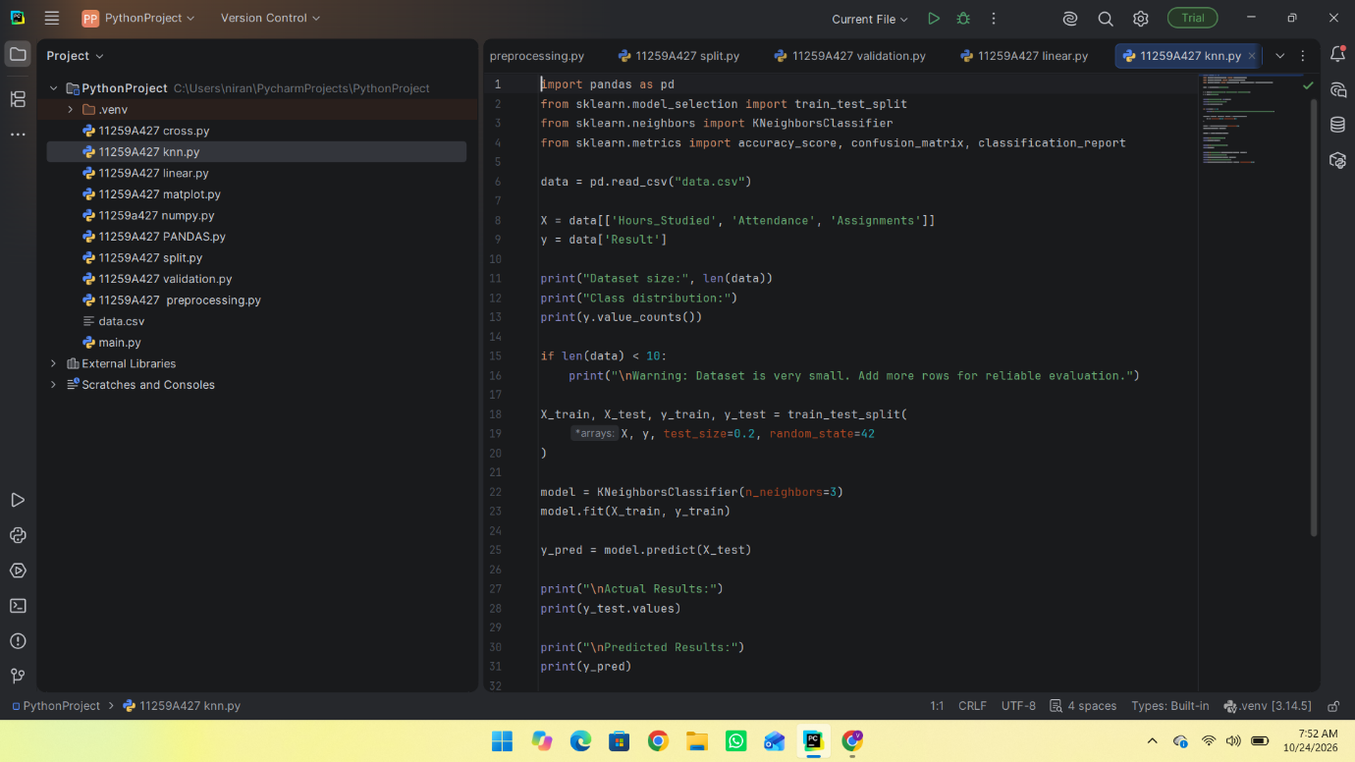

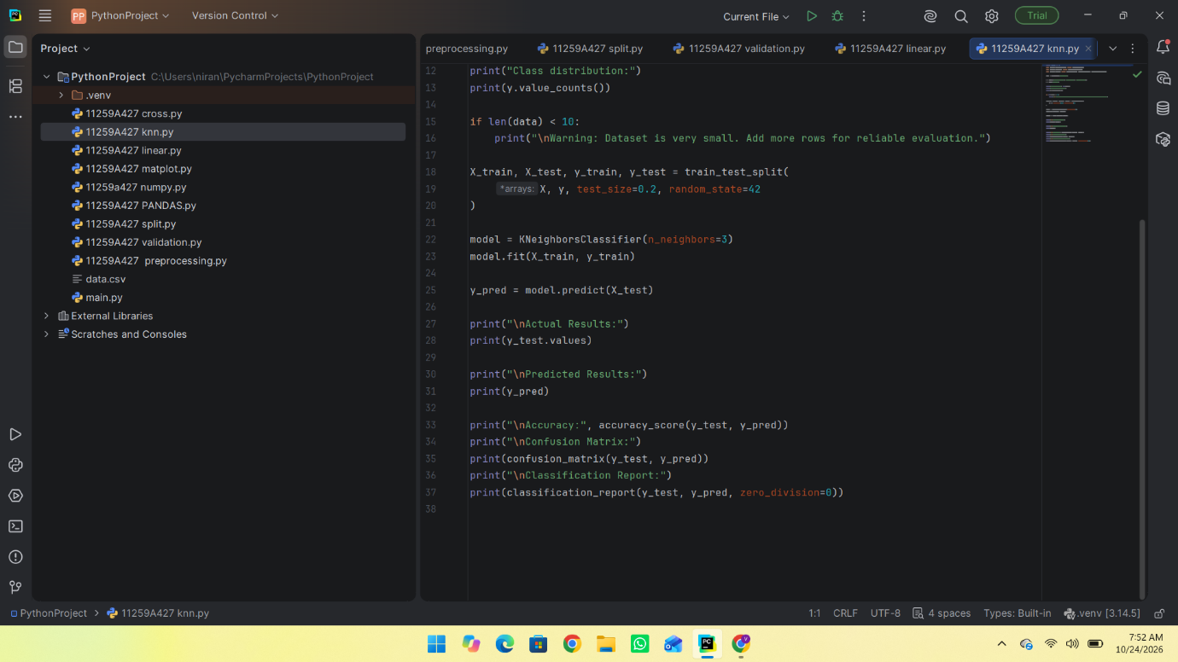

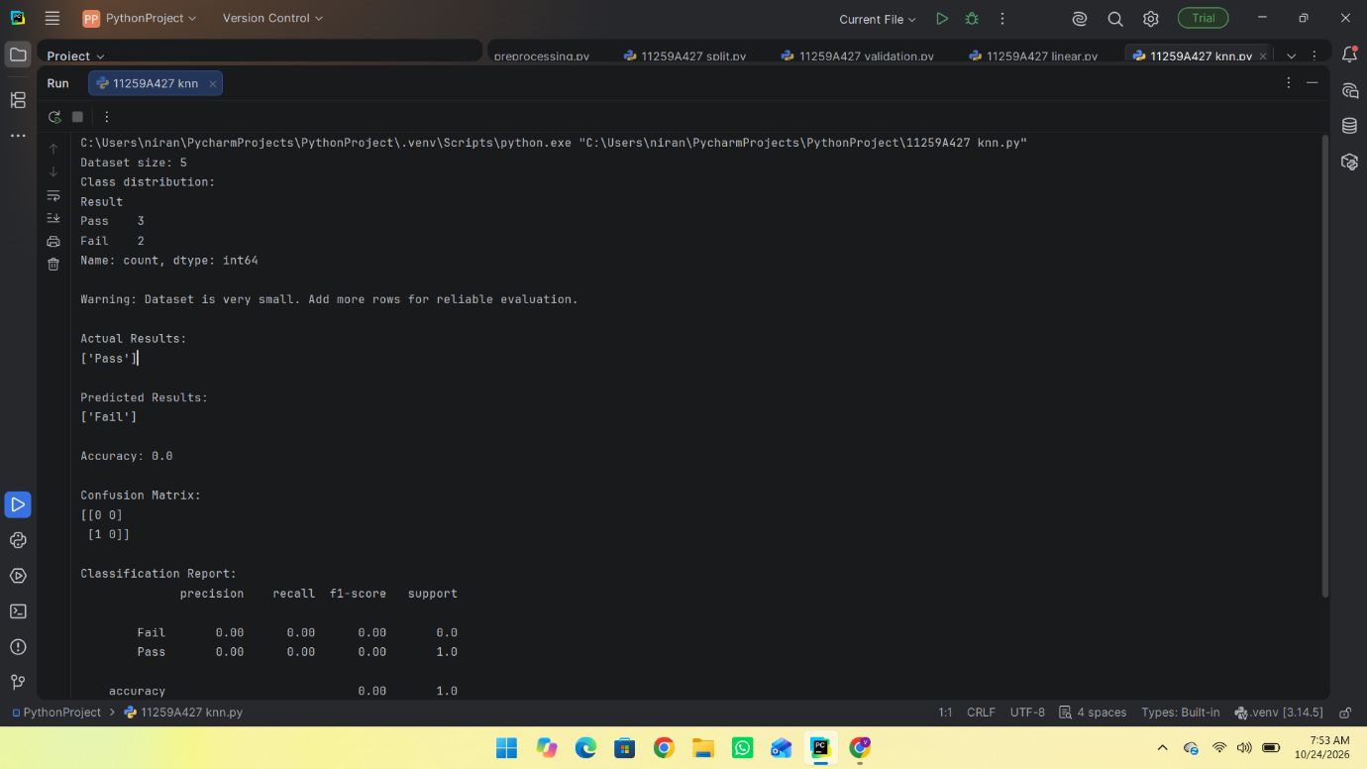
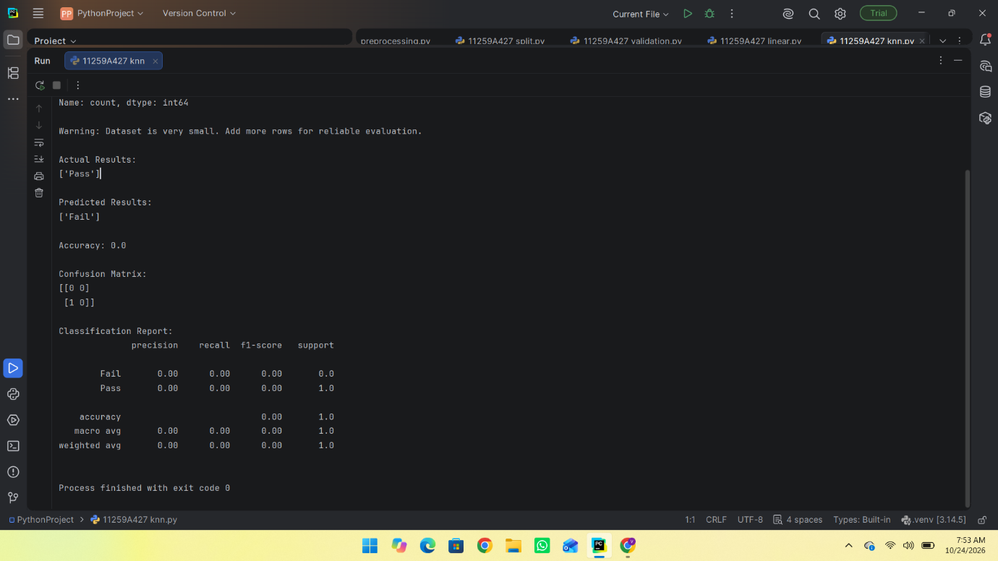

RESULT:
Thus, the K-Nearest Neighbors (KNN) classification algorithm was successfully implemented using Python to predict students' results.

